Using Erase for Math Fact Fluency:
- Foundational Fact Strategy Game for Addition
- Student focus is on making combinations of 10 (3 + 7, 2 + 8, 4 + 6, etc.)
- Ten frames present a natural tool for helping students identify combinations of 10.
- Students also need to know combinations of 10s to find missing addends as in 9 + __ = 10 or 7 + __ = 10.
- This is the type of thinking behind the making 10 and pretend-a-10 strategies where students must know how many are needed to make 10 or how far away a number is from 10.
- Erase is a particularly useful game for providing enjoyable and substantial practice in building this type of understanding.
About Games and Math Fact Fluency:
Games are fun. But, more importantly, games are effective ways to support learning. Games provide opportunities for:
- low-stress practice of (1) facts and (2) strategies (both outcomes are critical to math beyond the basic facts!).
- think aloud, an effective learning strategy. Therefore, students should develop the habit of verbalizing their mathematical thinking out loud.
- student listening and learning from peers. Therefore, discussing strategies before and after playing allows students opportunities to learn from each other.
- teachers to formatively assess and plan instruction. Therefore, at times, use an observation tool to record how students are progressing.
Effective math fact fluency games remove time pressure and allow students time to think. That means no time component. Each player has their own cards or dice to roll, so they are not racing each other. Scoring is de-emphasized. Thinking strategies are front and center.
Erase 2-4 players
Materials: A deck of numeral cards or playing cards with values 0–10 (aces = 1, queens = 0) OR seven 10-sided dice and a cup, calculators, recording sheet

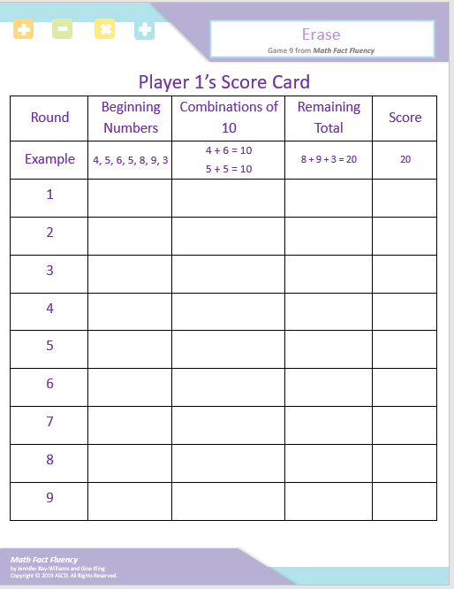

Erase 2-4 players
How to Play:
- Player 1 rolls all seven dice or turns over all seven cards.
- Pair as many dice as possible to make combinations of 10. (If using cards instead of dice, substitute cards for dice in remainder of instructions)
- Player 1 “erases” (removes) all combinations of 10 from their roll and these dice are not counted into the student’s score.
- Calculate the sum of the remaining dice (a calculator may be used if needed).
- Player 1’s score is the sum of the remaining dice.
- Player 1 records score on the recording sheet.
- Repeat all steps for Players 2-4.
- Play until time is up or for predetermined number of rounds.
- The player with the lowest score wins.

Game in Action:

Player 1 draws 4, 5, 6, 5, 8, 9, and 3.
Player 1 pairs 4 and 6 and 5 and 5, because they make combinations of 10.
Player 1’s score is the sum of the numbers that are left: 8 + 9 + 3 = 20
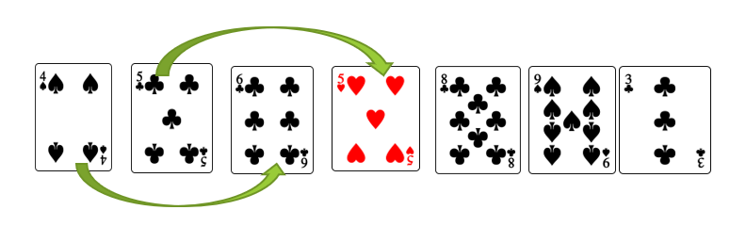
Possible Variations:
- Change the sum to 7 and use regular dice.
- Use fewer dice or deal out fewer cards.
- Designate a wild card (such as a king) so that more pairs may be made.

